**Standard Error**

The mean of population distribution is same as the mean of sampling distribution.

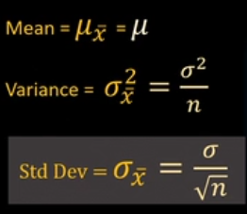

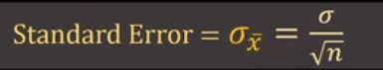

The Standard Error quantifies the precision of a sample mean.

As the sample size grows, the std dev or std error reduces.

**Z - Score Table**

z-score tells you how many std devs away the data point is from the mean.

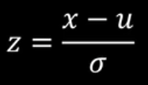

If you have z-scores, when you plot all z-sccores, you get std normal distn.

68.3%, 95.5%, 99.7% rule applies. In std normal distn, the area under entire curve is 1.

Q: What is the probability that a randomly selected person will have a height of 187 cm or less. Z-score table helps to answer these kind of questions. (mean = 170, std dev = 10)

Z(187) = (187 – 170)/10 =1.7

Open Z—score table and search for 1.7

The cumulative probability for the z-score 1.7 is 0.9554 = 95.54%